Barsha Maharjan is a creative enthusiast interested in exploring the dimension of VR and Motion Graphics. She is MFA second year student majoring in Design and Technology Graduate at Parsons School of Design. MFADT'19

Motion Capture Studio Trainer

I am currently working as a trainer and a Research Assistant at the Motion Capture Studio at Parsons School of Design. The system is from OptiTrack and the software we use is called Motive. The motions of this system is really smooth with 16 cameras looking into the space which are capable of capturing 250 frames per second.

1

This is doing the training session at the MoCap Studio. The rigid tracking bodies are attached on the suit of the actors which is captured by the cameras in the space. The cameras will then transfer the location of those dots to the software resulting in smooth motion transition.

<https://vimeo.com/258662767>

In the video, my friend Ray is dancing and we can see the seamless motion tracking of his movements on the screen.

----------

Mythical land user testing: <https://www.youtube.com/watch?v=BLgvC7mvTpU>

---------

### **Trick or Treat Game**

<https://www.youtube.com/watch?v=cc3u8_kE_kU>

Virtual touch

# Virtual Touch

The idea behind this project is to touch the virtual object on the screen using hand gestures.Here the hand gestures are controlled with leap motion and the software Unity is used to make Totoro jump.

### **Virtual Touch Initial Prototype**

This is the initial draft of testing the project where the interaction is working fine.

<https://vimeo.com/258879117>

### **Virtual Touch Final Project**

This is the initial draft of testing the project where the interaction is working fine.

<https://vimeo.com/258820122#at=0>

Project SORA

Speculative Air Polluted Environment

### **Drawing from what's happening now...**

People from lots of countries are facing the problem of air pollution. So, looking into the condition of the environment from these polluted areas, we thought of this environment where the air is so thick with smoke that we won't be able to see the surrounding clearly. This would directly hamper people's mood and emotion. According to a research , the people who are currently living in the most air polluted environment happened to experience its effect on their health as well as their mood and emotion.

2

We looked into the "AirVisualEarth" site which gives the real time visual of air pollution.

3

### **A Speculative Solution**

To fully eradicate the air pollution, it is going to take a really long time. So, we drew this solution where the user possesses an Umbrella which acts as an air purifier as well as it will have a projection of blue sky underneath it.

4 5

### **User Testing**

<https://vimeo.com/261634757>

Webpages

## [**Feet in 2 Worlds**](http://www.fi2w.org/)

FI2W is a social work company telling the stories of today's immigrants and bringing diversity to America's newsrooms. They needed to revamp their website so my responsibility was to create a new look of the website. The new website is in the developing stage.

The prototype version can be found in the [**invision app link here**](https://invis.io/MEOGVNEFH46)**.**

Previous Version of the Website

6

## **Logo Variations**

Selected Logo

HWF

Ellie Skeele. the owner of Himalayan Wild Fibers wanted a total revamp of her website and also the brand identity of her product. So, I delivered what she asked for.

[**Bootcamp 2018**](http://bootcamp.parsons.edu/)

Bootcamp is an annual event of 3 weeks that takes place for all incoming MFADT students. We created this site as a way of facilitating them about what they can expect to be doing and learning during the bootcamp.

[**Nepal HipHop Foundation**](https://nepalhiphopfoundation.org/index.html)

Nepal HipHop Foundation is a non-profit organization which is bringing revolution in the HipHop scene in Nepal with combined help from the US Embassy.

[**Raju Gurung**](https://rajugurung.info/index.html)

Raju Gurung was my mentor. I designed and developed his website.

Travel

# [Berlin / Paris Memories](https://www.barshamaharjan.com/travel/2018/12/18/berlin-paris-memories)

[December 18, 2018](https://www.barshamaharjan.com/travel/2018/12/18/berlin-paris-memories)

Professor: Sven Travis, Brad MacDonald

This fall 2018, students from Parsons School of Design, New York and Köln International School of Design, Germany collaborated on a course called Berlin/Paris VR Jam. The students from Parsons went to Berlin and Paris to collaborate with KISD students and create projects related to these two places.

This blog consist of my individual project as the outcome of this course. I put together an experience of the arts that struck me the most on my trip to both Berlin and Paris.

The first museum that we went in Berlin was the Berlin Bunker Museum. The art that I found the most fascinating was the sculpture of a fierce looking hound which was siting upright as if guarding something. We were told that the hounds were the guardians of hell. We weren’t allowed to take pictures so I had the vision of the hound etched in. The sculpture of the hound here is guarding two doors.

Gif dog

When you go through the blue door, you will be taken to a room filled with the arts that I took pictures of at the streets of Paris and at the museum. There are two images from the street and one from the Museé du Louvre called Une scène du Déluge (Scene from the Deluge). While on site, I spent a lot of time looking at them specially Une scène du Déluge because there is something hauntingly beautiful about it.

<https://www.youtube.com/watch?v=uo-bY5NYFxI>

If you go through the orange door, you will come across arts from Berlin wall. Berlin wall is fragmented piece of a sad history, the remains of it are present in different part of the city. The wall that I visited consisted of arts by artists all over the world.

<https://www.youtube.com/watch?v=W6tRi98KHKA>

# [L'amour Paris](https://www.barshamaharjan.com/travel/2018/11/23/lamour-paris)

[November 23, 2018](https://www.barshamaharjan.com/travel/2018/11/23/lamour-paris)

Paris is a city of love. So, we went around different parts of Paris to take pictures of graffiti’s related to love and then we compiled them into a single poster.

We also took pictures of romantic places as inspiration for this project.

7-13

# [Light Bending](https://www.barshamaharjan.com/travel/2018/11/20/light-bending)

[November 20, 2018](https://www.barshamaharjan.com/travel/2018/11/20/light-bending)

With a topic of light and shadow in the context of narrow speculation, we experimented with how light bends and distorts if projected on different materials to make the shadow random while visually appealing. It turned out to be a series of generative art with the contrast of light and darkness as well as the superposition of diverse surfaces. Being squeezed, twisted and rotated, simple items in our daily could create surprising and amazing visual effects, which is one of the most impressive discoveries we found out.

<https://www.youtube.com/watch?v=Ca4eEbfWEgk>

Group 8: Barsha, Elena, Joyce, Stella

# [Zukunft Chambers](https://www.barshamaharjan.com/travel/2018/11/16/zukunft-chambers)

[November 16, 2018](https://www.barshamaharjan.com/travel/2018/11/16/zukunft-chambers)

Group 7: Arthur, Barsha, Stella, Xiaoyu

Zukunft Chambers stands for Future Rooms. We thought about the concept we have to follow, the “Future of work“ and “Room with a view". So, futuristic rooms where walls could be used as a display came up as our concept.

## **Concept Statement**

A futuristic room with interactive walls displaying videos of your memories, live video or a certain scenery.

If you are in a room you don’t have any control over the view of the walls. You might put a projector to display certain videos on the wall but you would be restricted by the luminosity, pixels etc. So, we propose a concept where the entire walls in the room are interactive. Even though you are bound to your room, you can choose the environment you want to be in and even go beyond the physical boundaries by choosing a space you prefer to work at. In other words, you are creating an imaginary space which is personalized to your preference.

15

Walls can be used as a portal for seeing what the other partner on a different part of the world is doing right now. So, instead of the wall being a physical barrier, it can be a way of connection between them.

For the prototype, we put together a room where the walls are displaying videos. The walls in the prototype consist of videos we took today in Berlin as well as videos of some scenery and other people.

<https://vimeo.com/301231113>

# [China Trip](https://www.barshamaharjan.com/travel/2018/11/13/china-trip)

[November 13, 2018](https://www.barshamaharjan.com/travel/2018/11/13/china-trip)

Day 1 : Conference

16

# Tonji University, Shanghai

17

18

19

# Perception Neuron

<https://www.youtube.com/watch?v=gJHP_OYN2KM>

<https://www.youtube.com/watch?v=SQZA_HqKV2s>

Narrative

# [Mandala Reading](https://www.barshamaharjan.com/narrative-and-dynamic-system/2018/12/17/mandala-reading)

[December 17, 2018](https://www.barshamaharjan.com/narrative-and-dynamic-system/2018/12/17/mandala-reading)

A mandala depicts several different meanings. It means the life, death, afterlife, the heaven, earth, hell and many more. The mandala I chose to do the reading is called Ashtamangala Mandala.

'Ashtamangala,' ashta meaning eight and mangala meaning auspicious. These eight symbols of good fortune represent the offerings made by the gods to Shakyamuni Buddha immediately after he gained enlightenment. In Nepal, we put these symbols on our doors to ward off evils and to welcome good fortune and health in the house.

Each of the symbols have their own meaning which resonates to everyone.

## **Conch**

In Buddhism, a white conch that coils to the right represents the sound of the Dharma reaching far and wide, awakening beings from ignorance.



## **Endless Knot**

A symbol of eternity and unity. It is believed that the endless looping if the designs confused evil spirits and prevented them from entering homes.

The knot represents a connection, a link with our fates, binding us to our karmic destiny.



## **Golden Fish**

Represents joy, freedom and fearlessness. The fish symbolize happiness as they have complete freedom of movement in the water. They represent not fearing to drown in the ocean of suffering, and can freely migrate (chose their rebirth) like fish in the water.



## **Lotus**

Represents the primordial purity of body, speech and mind floating above the muddy waters of attachment and desire.



## **Parasol**

The protection of beings from harmful forces and illness. The canopy symbolizes preservation against suffering and sorrow

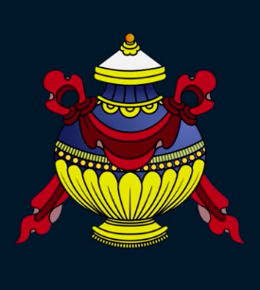

## **Treasure Vase**

Represents health, longevity, wealth, prosperity, wisdom and the phenomenon of space.

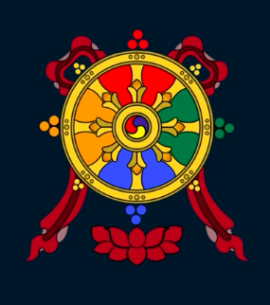

## **Dharma Chakra**

Represents the eightfold path leading to enlightenment: Right faith, right intention, right speech, right action, right livelihood, right endeavor, right mindfulness, and right meditation.

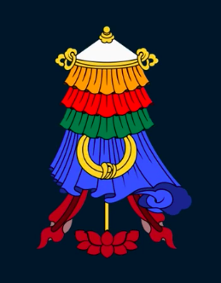

## **Victory Banner**

Symbolizes victory of Dharma over fear, ignorance and death.

## **The Making**

Since, I don’t have psychic power to know what the other person is dealing with right now, I replaced my lacking of this ability with technology. I made a 3D cut of the mandala and attached them with led light which would blink depending on the distance the tester would put their hand under the mandala. This is like their fate in a way because the led would first light up on the symbol according to the distance of the hand. This is the first step.

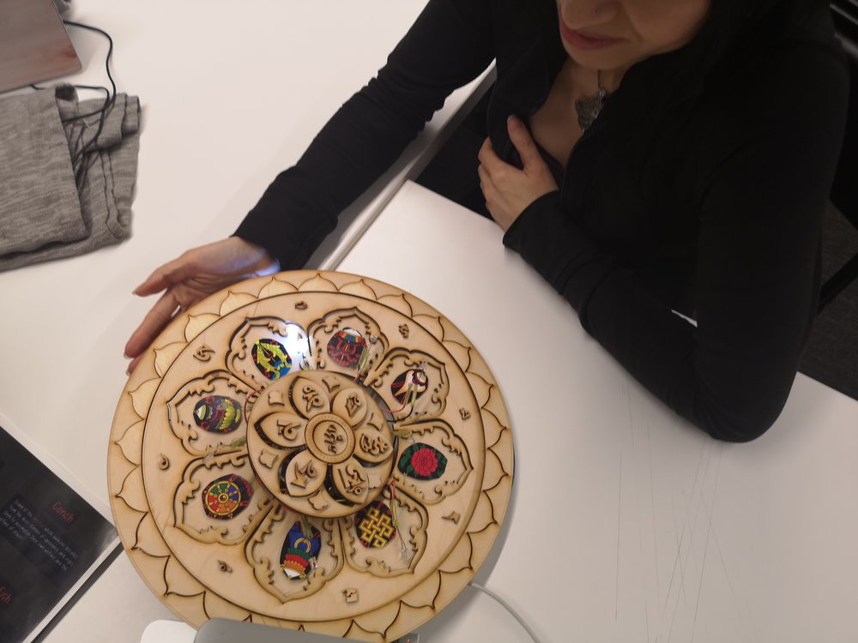

The second step if for them to choose a card from a deck of 8 mandala cards, this is like their choice in life. The first one is what the fate chose for them.

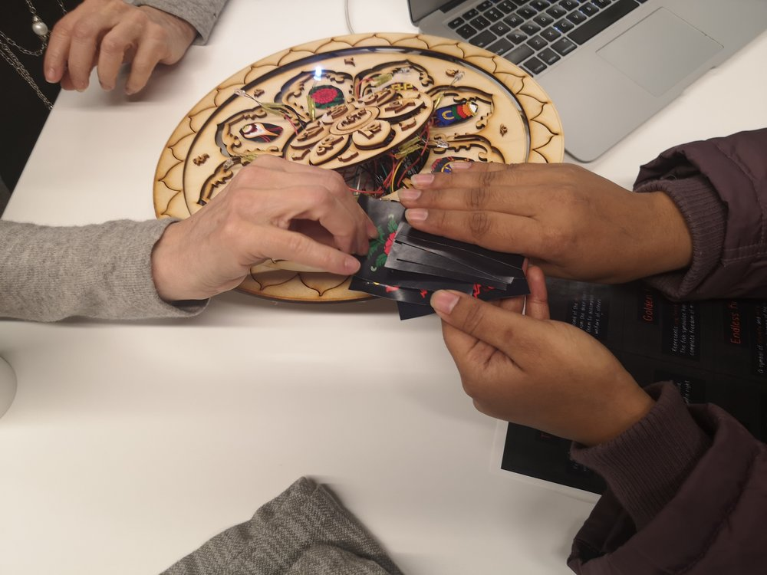

## **Testing**

Depending on which symbol on the mandala lit up first and the card that the tester chose, I would first them the meaning of both of them and later contradict the two symbols that they got. I took the symbol with light on the mandala as a positive element and the card they chose as a negative element in their life.  
  
For example, if the symbol “Golden Fish“ lit up in the mandala and then later they chose the card of “Endless Knot“, it would mean that the tester is as free as the fish in the water, fearless and happy but at the same time because they chose the “Endless knot“, even though they are free, there is something holding them back from trying out new things.   
  
Some of the feedbacks I got were:

* Contraption is very fascinating. Is the physical mandala necessary? Something more to it ? May be a Card of a physical object. Powerful with no questions and just the meaning of each card. Identify the future for them.
* Confusing her about the light. How accurate for the distance sensor. Don't let the lights go on and off.
* How can I get out from the Maze? No tools I need. How can she feel more empowered?

## **Reflections**

Some of the findings from the testing were that I need to build up the conversation and ask if the meanings that I am giving them resonates with their life and also to tell them what to do in order to get rid of any negative energy or hindrance thats holding them back. So, my next iteration for this project would be to take in the suggestions I received from the testers and make the symbols more meaningful.

# [This AI Can Write Your Horoscope](https://www.barshamaharjan.com/narrative-and-dynamic-system/2018/11/2/this-ai-can-write-your-horoscope)

[November 02, 2018](https://www.barshamaharjan.com/narrative-and-dynamic-system/2018/11/2/this-ai-can-write-your-horoscope)

I am really interested in horoscope. I was born on October 22nd so I am a Libra. Every morning I open a website called Astrology.com to look at what is written under the Daily Libra section. The section would have a paragraph with a set of writings about what would happen in the day. Things like, someone would bug you today and what you should do to avoid it, that someone will bring happiness to you today, take care of your finances, don’t spend too much, enjoy your time with your friends today etc.

It is interesting to read such writings of prediction because weirdly enough they do match to the reality sometimes. I would often forget about what I read in the morning but remember it if warns me of a major happening of the day. I never went to the detail of entering my time, date and place of birth which would mean that I am not a geek about it but just touching the surface is enough. Regarding the source of such prediction, I am not sure how they do it but I read it out of sheer curiosity.

The writings on the [website](https://motherboard.vice.com/en_us/article/59ydqk/this-ai-can-write-your-horoscope) might be written by an AI or a real astrologer. If it were a real person, coming up with these writings daily for 12 zodiac sings must be a tough job which is why I believe the trio Banu Guler, Ben Weitzman, and Anna Kopp decided to make an app out of it. They said it considers the real-time position of starts from NASA. Now, would I use their app instead of the website that I follow? Maybe not because I would not follow an AI predicting my daily outcomes.

Article: [This AI Can Write Your Horoscope](https://motherboard.vice.com/en_us/article/59ydqk/this-ai-can-write-your-horoscope)

# [How Tarot Cards Work](https://www.barshamaharjan.com/narrative-and-dynamic-system/2018/11/1/how-tarot-cards-work)

[November 01, 2018](https://www.barshamaharjan.com/narrative-and-dynamic-system/2018/11/1/how-tarot-cards-work)

I once had a tarot card reading done at school event. The tarot reader was a rather elderly woman. She had carefully placed a maroon velvet cloth over a small table and on the table, was some crystal-like stones. There was a long queue of people waiting to get their readings. I waited for maybe 30 minutes to get mine. When my turn came, she looked at me and gestured to sit on the chair. She had a deck on tarot cards with her. She asked me what question do I wanted answered. I asked “When will I meet my significant other?”. She looked at me with a sigh as though she had already heard this question a lot. She explained, I can only answer the question about career or family today. I said, “then let’s do career.” She shuffled her deck of cards many times, I lost count of it. She explained while shuffling that she cannot answer when I would meet my significant other because it was a specific question. After reading the article, I thought to myself if I had rephrased the question to not be specific would she have answered any curiosity of mine about my future partner. Maybe she would have or maybe not but tarot readings are interesting to me and I really like how a deck of card is able to answer what one’s future is going to be even though it may not be true.

Article: [How Tarot Cards Work](https://science.howstuffworks.com/science-vs-myth/extrasensory-perceptions/tarot-card.htm)

# [The Parallels Between Designing Immersive Theatre and User Experience](https://www.barshamaharjan.com/narrative-and-dynamic-system/2018/11/26/the-parallels-between-designing-immersive-theatre-and-user-experience)

[October 30, 2018](https://www.barshamaharjan.com/narrative-and-dynamic-system/2018/11/26/the-parallels-between-designing-immersive-theatre-and-user-experience)

It makes sense how the author related UX design to immersive performance in theaters. I often wondered in an immersive theater performance what would happen if the users do not want to participate or they are shy, what if they have stage fright or they deliberately act out differently etc.

The storytellers must review each of these possibilities before opening the show to the public. I assume that the show of immersive performance would take months of practice and iterations on the original idea because human nature is fickle and unpredictable. The thing that struck me about the article is when the author mentioned what if the audience were interviewed and a concept of the performance is developed later from the results. This would result in a more personalized storytelling because the user journey is as much important in storytelling as it is in UX. The audience must be able to follow through the story for it to make sense to them. In addition to making personalized story, sensory techniques like touch, sound, smell, taste can be added to the performance to make it realistic.

Article: [The Parallels Between Designing Immersive Theatre and User Experience](https://medium.com/@sophiapglee/the-parallels-between-designing-immersive-theatre-and-user-experience-543f32e07b5d)

# [Interactive Performance Styles](https://www.barshamaharjan.com/narrative-and-dynamic-system/2018/11/26/interactive-performance-styles)

[October 29, 2018](https://www.barshamaharjan.com/narrative-and-dynamic-system/2018/11/26/interactive-performance-styles)

Interactive performance styles, getting the audience to get involved in the piece of a performance is interactive and immersive. They would feel like they are the part of the story and their involvement is important to proceed with the storytelling of the performance.

The creators and the actors on stage would have to improvise with the performance done by the audience. Also, the story would need lots of iterations considering every prediction of the steps that the audience would take in the play. I would call it a highly improvised and interactive performance. The actors on stage would have to change their plans, scripts, dialogues and their roles according to their audience’s play. I wonder if the act is improvised too much would the final performance reflect the original concept?

Most of the styles in interactive performance are tested several times throughout every predicted behavior of the audience. For example, in treasure hunt, the audience are called onto the stage and given the role-play of treasure hunter. In this scenario, all the possibilities of the audience finding out the treasure is pre-tested. Certain clues can be given to prevent the audience from taking too much time. I imagine the testing phase of the performance to be longer. However, if any unpredictable situation arises there would be pro actors who would direct the audience back to the story.

Article: [Interactive Performance Styles](http://www.bohointeractive.com/tech-niques/styles/)

# [Chris Crawford on Interactive Storytelling​ : Abstraction](https://www.barshamaharjan.com/narrative-and-dynamic-system/2018/10/17/chris-crawford-on-interactive-storytelling-abstraction)

[October 17, 2018](https://www.barshamaharjan.com/narrative-and-dynamic-system/2018/10/17/chris-crawford-on-interactive-storytelling-abstraction)

Interactive storytelling needs some sort of interaction from the audience. So, when the audience is in control choosing the next part of the story, the creator would have to think about multiple ways so that their main theme of the storytelling would not falter. Keeping an abstract form of terms rather than specific plot seems to be a solution to this problem where we are restricting the audience to think about certain themes and to act in a certain way. I found the example story of the dialogues between Grandfather and little Annie to be interesting because her grandfather is changing the story as per Annie’s remarks along the storytelling process. Id this were to be done in a professional setting with a large audience, I would hardly believe that the story would ever come to an end but it could if the audience would jointly agree on ending the story.

# [Creating interactive narratives](https://www.barshamaharjan.com/narrative-and-dynamic-system/2018/11/14/creating-interactive-narratives)

[October 17, 2018](https://www.barshamaharjan.com/narrative-and-dynamic-system/2018/11/14/creating-interactive-narratives)

In a point during the interview with Ingrid Kopp mentions that every project does not necessarily need to have an interactive element whether it be fiction or non-fiction work. It depends on ones strategy, their audience, artistic vision. I played the interactive story called [Alma](http://alma.arte.tv/en/webdoc/) which uses a gesture based interactivity with videos to tell story about a woman and her involvement with a violent gang. The interactivity may be subtle but the content of the story and the narrative has a strong impact on the audience since it is being told by the person who experienced it. So, I think depending on the narrative and the story, the creator can opt to have less or interactive elements but the message must be able to pass though to the audience.

# [I-Docs](https://www.barshamaharjan.com/narrative-and-dynamic-system/2018/10/17/i-docs)

[October 17, 2018](https://www.barshamaharjan.com/narrative-and-dynamic-system/2018/10/17/i-docs)

‘When I speak of poetry, I am not thinking of it as a genre. Poetry is an awareness of the world, a particular way of relating to reality’ – Andrei Tarkovsky

Interactive Documentaries can be explored in multiple mediums like interaction between computer and human, human and human, human and nature. However, when I think of interactive documentary, I immediately picture an interaction between human and a digital interface in the form of tapping on screen, swiping, clicking etc. After reading through the article [i-docs](http://i-docs.org/2016/03/27/interactive-documentary-what-does-it-mean-and-why-does-it-matter/), digital interactive documentaries includes procedural, participatory, encyclopedic and spacial. These elements are being followed in the interactive documentary called [“Digital me“](https://digitalme.heliosdesignlabs.com/#!/conversation) where the audiences are made to interact with the digital version of themselves through social media accounts. They created it with a set of pre-fed definite dialogues that the audience have to click through to proceed with the conversation. I found this rather interesting because the website takes in real time data to interact with their audience.

# [Four Ingredients of Story: Plot](https://www.barshamaharjan.com/narrative-and-dynamic-system/2018/9/26/four-ingredients-of-story-plot)

[September 24, 2018](https://www.barshamaharjan.com/narrative-and-dynamic-system/2018/9/26/four-ingredients-of-story-plot)

I would like to mention a game for this post. This is the only game that I cried to at the end because of it amazing storytelling. The name is Ori and the Blind Forest. If I have to revisit the game, I see a great plot and evocative storytelling style.

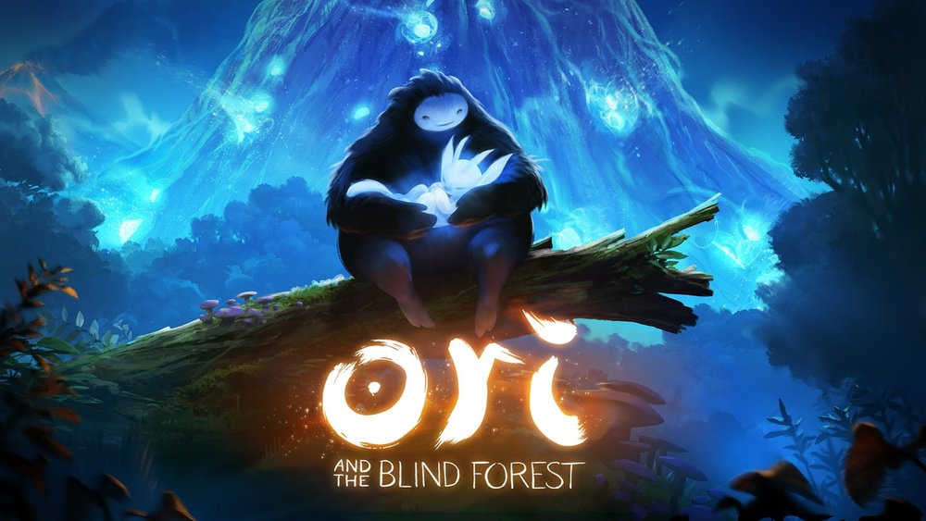

Plot: Ori is an orphan that Naru adopts and later in the story Ori finds that he is destined to save the entire valley from destruction.

Even though the plot is really simple, its the conflict that the player goes through as Ori. It makes us sympathetic to the character and we become sad when the character is not succeeding. Along the gameplay, there are several narrations and dialogues with what sounds like ancestral voices of the trees making it feel like we are being guided. Each level are a hook and the players are left with the curiosity of what adventures the next level would bring. The gameplay in combination with the audio and the majestic atmosphere makes this game worth the time spent playing it.

# [The 5 Essential Story Ingredients](https://www.barshamaharjan.com/narrative-and-dynamic-system/2018/9/26/the-5-essential-story-ingredients)

[September 23, 2018](https://www.barshamaharjan.com/narrative-and-dynamic-system/2018/9/26/the-5-essential-story-ingredients)

These 5 story ingredients are found across movies, novels, basically most of the stories. Orientation, crisis, escalation, discovery and change are like a mantra for storytellers.

I would like to give an example of a horror movie

**Shutter**

Shutter is a Thai horror movie that gave me goosebumps for the first time. If we go to its events, we can find these 5 process of storytelling.

* **Orientation:** The protagonist is a photographer. He is seen with his girlfriend and we can see that they are in a good relationship. However, the environment setting is gloomy giving us an eerie feeling like something is going to happen.
* **Crisis:** The protagonist starts having strange occurrences that he cannot comprehend.
* **Escalation:** He starts to become paranoid and haunted by a girl’s ghost. It intensifies when his friends die one after another.
* **Discovery:** He realizes that the ghost is someone that he did wrong to in the past and that’s why she came to get her revenge.
* **Change:** They figure out a way to make amends and let the ghost rest in peace. However, she would later be found still attached to the protagonist.

# [The Art of Storytelling and Narrative in VR](https://www.barshamaharjan.com/narrative-and-dynamic-system/2018/9/25/the-art-of-storytelling-and-narrative-in-vr)

[September 13, 2018](https://www.barshamaharjan.com/narrative-and-dynamic-system/2018/9/25/the-art-of-storytelling-and-narrative-in-vr)

Storytelling in VR adds another level of interactive experience by surrounding the audience inside the world of the author. The article suggests that we ask ourselves three questions while creating a story, which are: (1) What is the user doing? (2) Why are they doing it? (3) And how will they discover what “matters,” i.e. what’s worth doing? These questions makes more sense in VR storytelling where the users are free to roam inside the world of the storyteller. So, it important to determine what the users are doing in the environment, why are they interacting with certain objects, and how will they find out what they are supposed to do in the world they are in.

**Learning and Exploration**

In VR storytelling, the audience would naturally want to interact with the objects around them since they are free to do anything they want. So, the article states including tutorials and instruction into the narrative itself is a good strategy to get the audience started on with the objects in space. This I found really useful and I have seen it being used in the games like, Ori and the Blind Forest, Harry potter, etc, where the players are taught how to interact with the objects throughout with a narrative.

**Player Attention**

I think it is best when the creator of the story doesn’t have to explain the audience about what the interactions are but rather the audience should be able to figure it out themselves which could be done by adding certain guiding elements in the space. This can be achieved using the lights, scale, colors, mood etc

**Interface Design**

The article mentions about leap motion and how we can use hands to interact in the virtual word just like our own hands. It says ,”Since hands are a part of ourselves, we also tend to think of them as distinct from the rest of the environment”. This is true, if we make real life like objects in space, we won’t be needing to explain the player about how to use them.

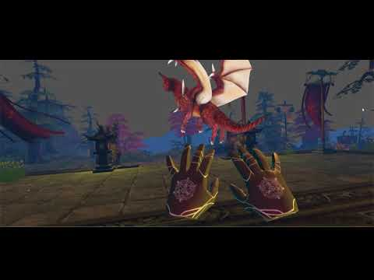

**Crafting the Journey**

In VR the players are creating their own story. The creators might want them to interact in a certain way but unlike video games on a screen, the players are able to roam freely in space. Hence, we as creators have to think about every likely possibilities and carefully craft the stories so that the main theme goes to the audience no matter how they interact with the objects in space.

Article: http://blog.leapmotion.com/art-storytelling-narrative-vr/

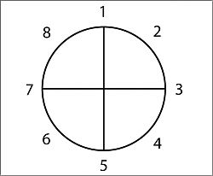

# [Story Structure 101: Super Basic Shit](https://www.barshamaharjan.com/narrative-and-dynamic-system/2018/9/26/story-structure-101-super-basic-shit)

[September 12, 2018](https://www.barshamaharjan.com/narrative-and-dynamic-system/2018/9/26/story-structure-101-super-basic-shit)

The author of the article mentions rather than giving a straightforward story to the audience, we give them twists and turns with lots of different events. The pattern as written in the article are as follows:

1. Character is in a zone of comfort,
2. But they want something.
3. They enter an unfamiliar situation,
4. Adapt to it,
5. Get what they wanted,
6. Pay a heavy price for it,
7. Then return to their familiar situation,
8. Having changed.

Lots of movies and games follow this pattern in a subtle way. In every action or romantic movies we watch we can guess and sometimes know what the ending is going to be. However, even when we know that at the end in a movie, the protagonist is going to destroy evil and bring peace, we tend to stick around and watch the entire thing because it is the journey/ drama that we are curious about and not the ending. We want to know how the protagonist faces his fears, persists and overcome the odds.

*0 Likes*

*Share*

# [Designing Branching Narrative](https://www.barshamaharjan.com/narrative-and-dynamic-system/2018/9/26/designing-branching-narrative)

[September 11, 2018](https://www.barshamaharjan.com/narrative-and-dynamic-system/2018/9/26/designing-branching-narrative)

I am not that fond of branching narratives because I think it is a method to just make the story longer and progressive choices can become annoying. Although, it would give us lots of ideas while creating narrative branches, it often sometime is I believe more work in the audience’s end and I believe they are often left hanging about the other options in the stories that they did not click.

However, I found Planning with Graphs to be an interesting process because we used this method slightly in twine and it made it easy to the create a simple interactive story.

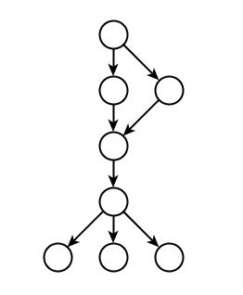

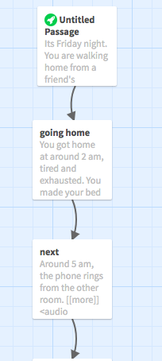

Story: http://philome.la/barshamhr/a-morning-call/play

The way I created this story is:

I knew the characters, the world they are in and some of the possibilities that could happen to them. I had an idea about the overall plot to the story. That was step one. The next step was to add the sideline stories to it, like where she was during the night (partying with friends), what she did when she got home (made her bed), went to sleep and then the abnormal things started to happen(plot).

# [Interactive Narrative: An Intelligent Systems Approach](https://www.barshamaharjan.com/narrative-and-dynamic-system/2018/9/26/interactive-narrative-an-intelligent-systems-approach-1)

[September 09, 2018](https://www.barshamaharjan.com/narrative-and-dynamic-system/2018/9/26/interactive-narrative-an-intelligent-systems-approach-1)

Machine learning, Artificial Intelligence, Cognitive Recognition etc are becoming an inherent part of the technological advancement. This advancement has touched various aspects of our storytelling methods as well. The story that the author created can now have different variations depending on the audience. The story’s atmosphere, mood, sound, events can completely change to adjust the audience experiencing it.

Last year at Maker Faire, I got to play an interactive storytelling installation where depending on which buttons we choose we get to determine whether the protagonist gets to go on a date with the girl or not. Honestly, in my opinion, even though the story was well made, I felt it was not complete. I mean there were several buttons that I did not press but I was already at the end of the story. So, I think the author should be the one controlling the flow of the story and not the audience because we will be missing the bigger picture i.e. the story.

Although, machine learning might make a story interactive and more appealing but I think it won’t have the same effect as the traditional means of storytelling.

# [Thesis Portfolio](https://www.barshamaharjan.com/blog-2/2018/12/14/thesis-portfolio)

[December 13, 2018](https://www.barshamaharjan.com/blog-2/2018/12/14/thesis-portfolio)

My interest lies in history, culture and technology. So, for my thesis project I was looking into topics by which I could integrate all of them into one. I am interested in knowing how some things came to be and by what ways are people still following them from the ancient times. They can be festivals, traditions, stories from the past etc. I am from an ethnic community called Newars of Nepal. They take up 5.6% of the total population.

Even though the community is small, they are rich in culture. They have their own unique festivals, architecture and language. However, since the past few years there have been sharp decline in the interest of young people in these ancestral elements.

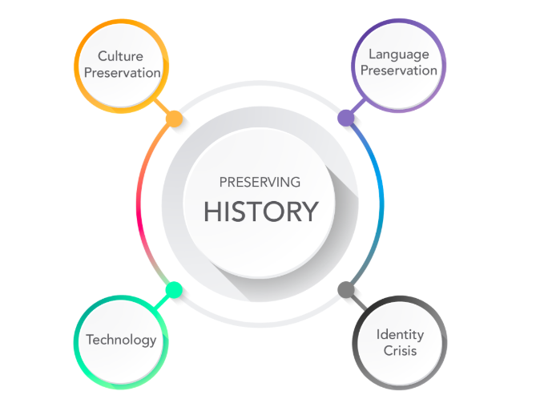

I am making a digital game that highlights Newari Culture and Language so that the players will be able to learn some words in the process of playing. During the testing phase of my game, I was asked why would people want to play this game despite knowing that the language was about to go extinct and why would they want to invest their time despite knowing that it won’t be useful for them for any purposes. My answer to that question was, Newari Language is deeply inhibited in Newari people and culture, if this language were to go extinct, the future Newari generation would feel lost and have a sense of identity crisis and it is very likely possible that they would blame us for not having continued using it and done anything to prevent that from happening. So, my project reflects my own feeling of being lost when I found out that I could neither read nor write my own ethnic language. Since, Newari language defines my root and my ancestry, I felt that I should step forward and make something rather than me being a bystander and watching my language become extinct.

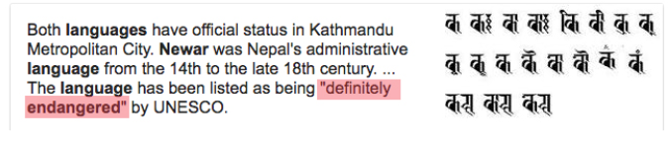

Endangered Newari Language

According to UNESCO, not only Newari language but as many as half of the world’s 7,000 languages are expected to be extinct by the end of this century; it is estimated that one language does out every 14 days. So, being a part of this century while some of these endangered language still exists, I intend to attract young generation so that my ethnic language would not go extinct at the end of this century. In the case of Written Newari Language,our Grandparents were mostly farmers and they were illiterate so even though they did well passing down the spoken language, they had no means of teaching written Newari language to their kids. However, even if they could afford to go to school then, they would be taught in Nepali. So, in a way, they had little or no means of learning the written language.

When I first started the project, I was focused on Newari Language and how I can teach the Newari youths to read and write in Newari. However, as I took interviews and researched more about the topic of language, my focus shifted towards introducing words rather than teaching the language. I found out through series of interviews that language is not a singular element there are histories and cultures associated with it. So, my main goal for this project now is to show cultural appreciation and not language.

# Prototypes

## **Board Game**

For the first prototype of my Newari language preservation project, I made a board game to check how the players will recognize patterns of letters to combine them into correct order to make a word.

I took the board game **Scrabble** as one of my precedent where you make word out of letters. Making a word out of letters if done consistently would help the players to recognize patterns and ultimately memorize that word. My other precedent was **Snakes and Ladders** board game where the players had to climb up ladders to go few blocks ahead or drop down few blocks if they are bitten by a snake. The mechanism of being bitten by a snake, dropping the blocks and replaying to go up the blocks is what I found useful in my board game because repetition of putting forward the letters to make the words is my way of making them recognize the words.

The components of my board game are:

Board, Dice, Player block, Letter cards

- The boxes are numbered in Newari and below each is their english number translation

- The black masked creature are called “Khya”, a term used to describe a ghostly creature in Newari mythology. Any encounter with them is followed by severe illness and even death.

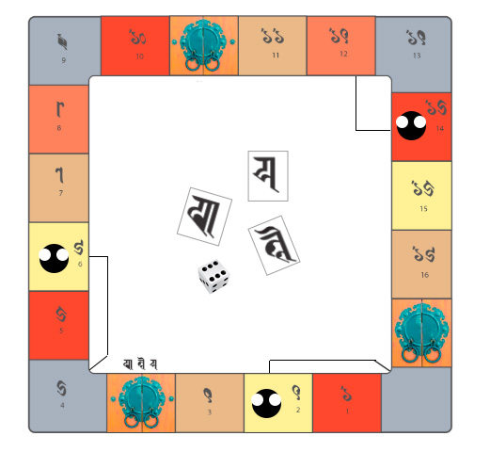

**Gameplay** (Two Player Game)

* The players start from the bottom right side
* They will roll the dice and pick up a word card
* They will move their “block” respective of the number on the rolled dice
* If there is a door along the way as they move their block, they will have to spell out the words “Ko le ya” meaning “open” with the cards they collected.
* The clues are written above the doors, these are hidden when they reach the second door. So, the players will have to remember the combination of the words.
* Encounter with “Khya” would cause the players to drop two steps down.

**Findings**

The user test showed that the players memorized the words according to their curves, lines and its repetition. Before playing the board game, I made them memorize the individual words as well as their their sound and pronunciation. However, they were able to recognize the visuals easier than the sound.

The board game as it is now only focuses on one word which is the Newari word for “open”. So, the future iteration would be to include more words to further know the pattern recognition of the players in one game. The strategy is to make the learning process seamless by making the gameplay fun so that the players would learn the letters without them knowing that they are learning.

## **Digital Game 1**

This is the first prototype to check if picking up the letters and arranging them is going to be feasible and easy  for the player. After testing, this turned out be a rather complicated step because the player had to jump with the letter block and dropping them in correct other was not easy.



## **Digital Game 2: Character Development**

For my second digital prototype, I focused on the character development. I took Kumari, as my main character. Kumari is a traditional practice in Newari culture where a young girl is revered as a living goddess and believed to have power to protect the nation from evil forces. However, designing the character and the environment took a really long time, so I decided to focus on the game mechanics.

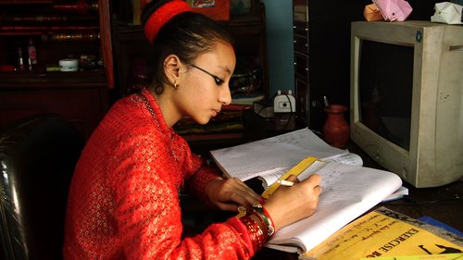







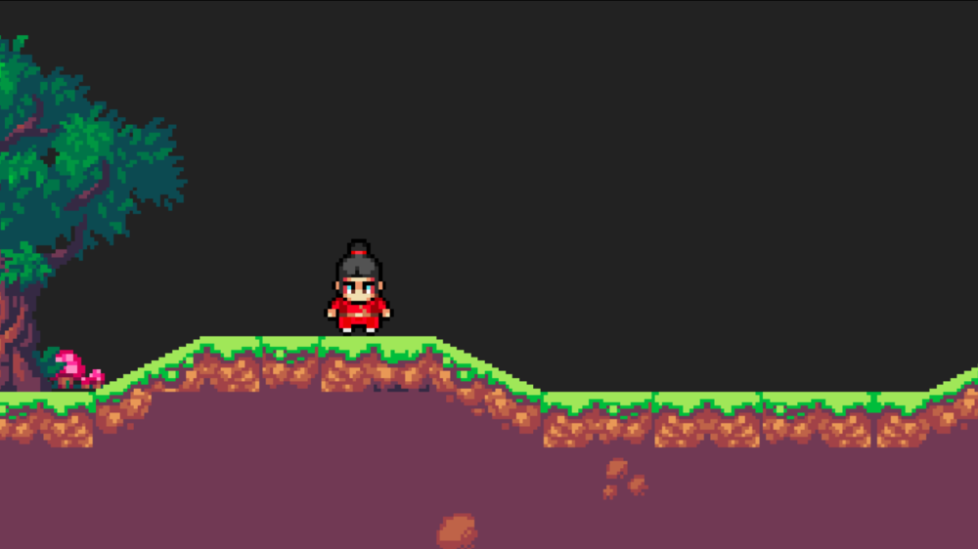

## **Digital Game 3: NeKu**

Focusing on the game mechanics for the game, I listed few of the basic interactions below:

* Pick up the letters and arrange them in the correct order to open the gate
* Shoot enemies to get to the door
* Each level will consist of a new newari word that the player has to arrange to go to the next level
* Use the mouse to shoot, the arrow keys to move and press the key “E” to pick up the words



The players will be introduced a new Newari word through out the game. This is one of the newari word for Fire. The character is going to shout “Mi” everytime they shoot fire so this word will be constantly reminded to the player.



## **Findings**

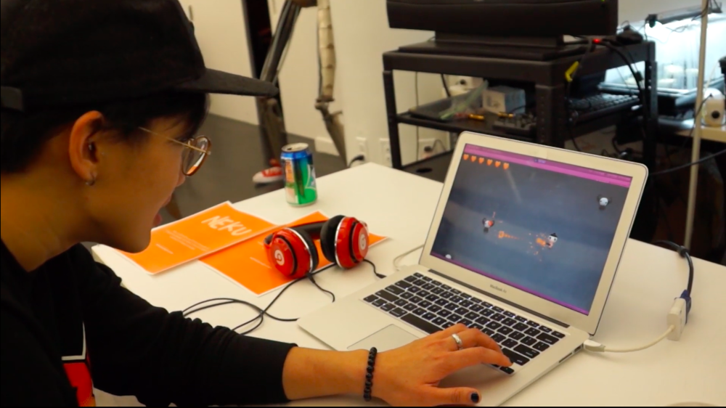

After doing the play test at the thesis pop up show, some of the responses I got were that the controllers were hard to navigate and that there needs to be a storyline as to why they are arranging the letters and killing the enemies. Even though I had put instructions in the first to stages mentioning the game mechanics, the players seemed to click through without reading them. Some of the suggestions were to include a summary of all the newari words used in the game along with their english translation.

So, my next iteration for this project would be to create a storyline, add new levels and making the graphics with elements from Newari culture.

# [GDC: 20 years 20 lessons Learned](https://www.barshamaharjan.com/blog-2/2018/9/11/gdc-20-years-20-lessons-learned)

[September 11, 2018](https://www.barshamaharjan.com/blog-2/2018/9/11/gdc-20-years-20-lessons-learned)

Recently, I watched a video from GDC. It was a talk given by the developer of Magic Game.

It was an interesting 60 minutes watch where he mentions what he learned over the course of making a game for 20 years. The points are the golden rules for making any game.

1. Fighting against human nature is a losing battle
2. Aesthetics matter
3. Resonance is important
4. Make use of piggybacking
5. Don’t confuse “interesting with “fun“
6. Understand what emotion is your game trying to evoke
7. Allow the player the ability to make the game personal
8. The details are where the player falls in love with the game
9. Allow your players to have a sense of ownership
10. Leave room for the player to explore
11. If everyone likes your game, but no one loves it, it will fail
12. Don’t design to prove you can do something
13. Make the fun part also the correct strategy to win
14. Don’t be afraid to be blunt
15. Design the component for the audience it’s intended for
16. Be more afraid of boring your players than challenging them
17. You don’t have to change much to change everything
18. Restrictions breed creativity
19. Your audience is good at recognizing problems but bad at solving them
20. All of the lessons connect

<https://www.youtube.com/watch?v=QHHg99hwQGY>

# [A day at Unity Developers Conference](https://www.barshamaharjan.com/blog-2/2018/9/11/a-day-at-unity-developers-conference)

[September 11, 2018](https://www.barshamaharjan.com/blog-2/2018/9/11/a-day-at-unity-developers-conference)

A productive day filled with information on new unity advancements. At 8am, I reached the Microsoft office at Times Square to help setup my friend’s project for the Unity Developers Conference on Saturday (8th September, 2018).

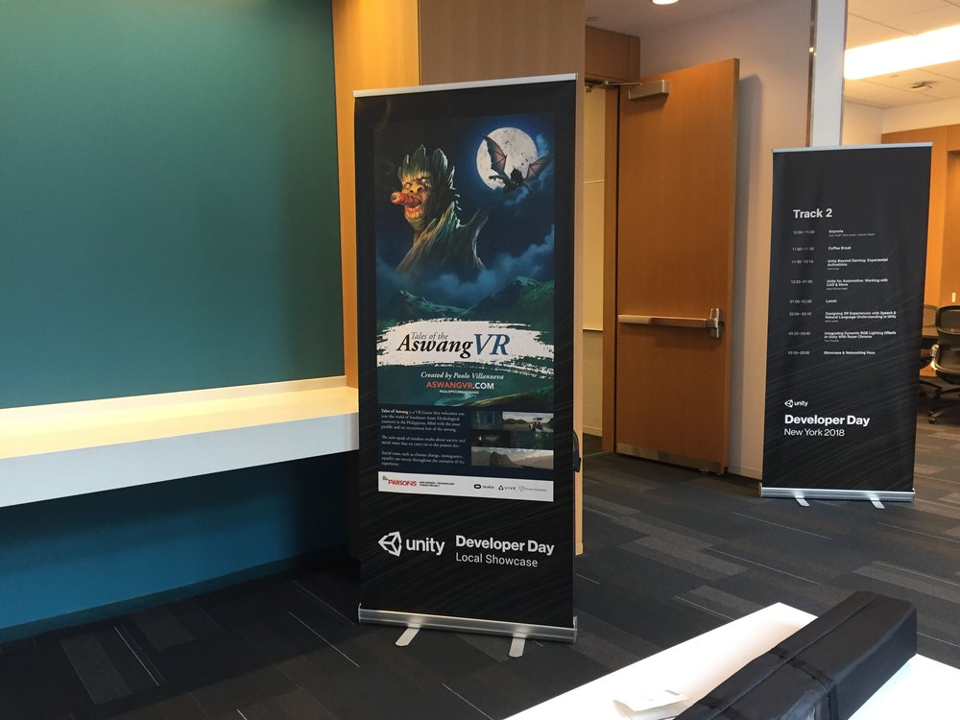

I picked up the banner from the organizers and set it up - [Tales of the Aswang.](http://aswangvr.com/)

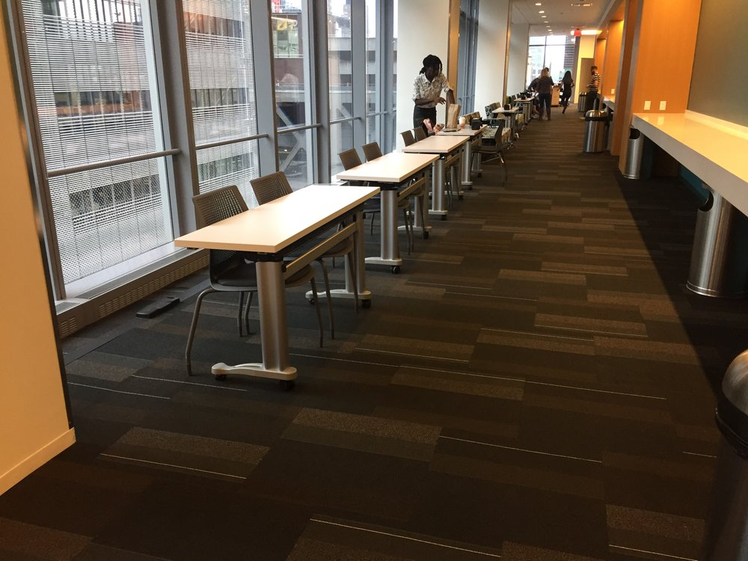

The event opened to the public at 9am so I had a brief moment to stroll around and look at other developers setup their work.

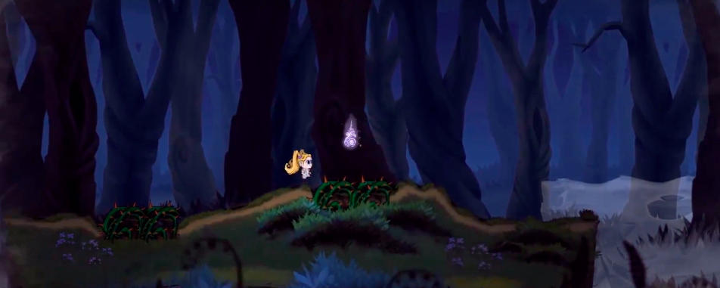

There were 9 games shown at the event, I got to play [ParaLily](http://paralilygame.com/) which had a spooky vibe to it almost similar to that of Limbo but I am not used to using xbox controllers so it took a while to get used to it but I really liked the concept and how the character shifts through different dimensions throughout the game.

I had the chance to play Ori and the Will of the Wisps as well. They had such amazing visuals never stops to surprise me. I had a chance to talk with few people from the industry as well. Overall, it was a really informative event.

# [Second Elevator Pitch (Thesis 1)](https://www.barshamaharjan.com/blog-2/2018/9/4/elevator-pitch-thesis-1)

[September 04, 2018](https://www.barshamaharjan.com/blog-2/2018/9/4/elevator-pitch-thesis-1)

### **Brainstorming**

**First Project Pitch**

My first project pitch was related to preserving the written Newari language which is listed as an endangered language in the United Nations. My elevator pitch was **"I am focusing on the preservation of my indigenous language called Newari which is recognized by the UN as one of the most beautiful languages in the world through the means of emerging technology."**

After brainstorming, I found out a few causes about why the language got to the point of extinction. I found that even though the written Newari language is in dire need of preservation, the spoken language is also showing signs of disappearance among the population.

In the case of **Written Newari Language,**our Grandparents were mostly farmers and they were illiterate so even though they did well passing down the spoken language, they had no means of teaching written Newari language to their kids. However, even if they could afford to go to school then, they would be taught in Nepali. So, in a way, they had little or no means of learning the written language.

The reason to why **Spoken Newari Language**is showing the signs of disappearance is because the root of the problem starts in school. The kids/people who speak Newari has a peculiar accent when they speak Nepali. So, because of this accent, we are often bullied, called on names, taunted at work and most of the times perceived as being dumb. Hence, the kids in school, are ashamed of their ethnic language and opt to be more fluent in Nepali instead of Newari. However, I have seen some of my classmates from school who take pride in speaking Newari and often use it to have a secret conversation. I see it as being a cool factor or a trend to preserve spoken language since most of the youths from my generation cannot speak it well.

Hence, the solution I came up with to preserve my ethnic language is making an Interactive Game including the "cool factor", to attract more youths because they are the ones who can preserve them.

## 

## **Brainstorming**

### **Rapid Ideation**

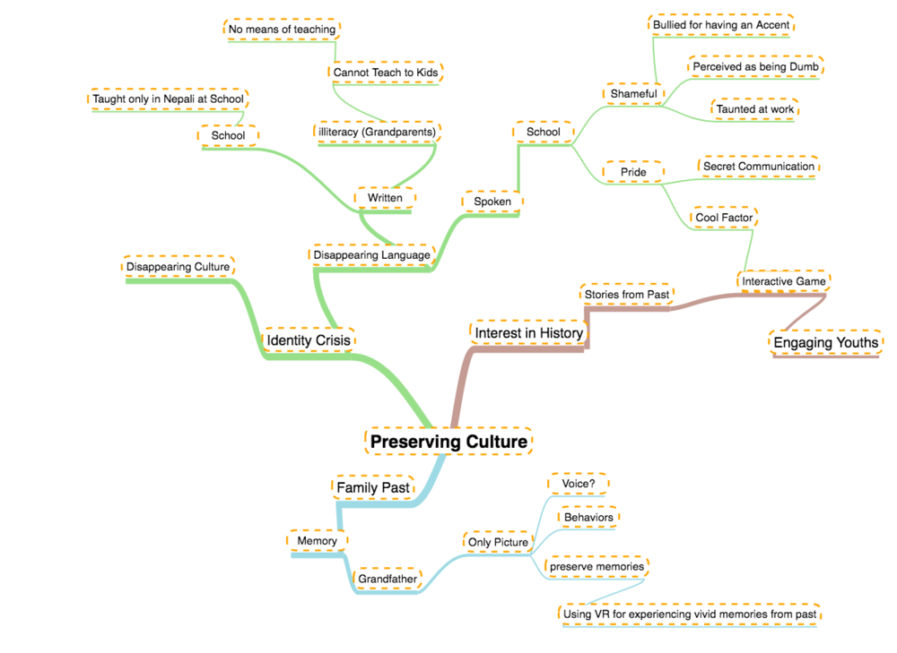

                  This Domain Map is an extension of my first and second project pitch

**Second Project Elevator Pitch**

My paternal grandfather died from tuberculosis before I was born. My only memory of him is a black and white picture and the stories that my father and grandmother would tell about him. There was not a technology back then to record videos so I always wondered how did he talk, what were his typical days like, how did he walk, etc. This is always going to be a missing piece of my past.  
  
Hence, this thought of my Grandfather led me to think about what if there were a technology that would record a particular day from the now and preserving these memories for later years. This is what videos would do as well but videos are 2D and you would not be able to fully perceive what this person was like. So, I had this idea of recording a video of now with a 360 camera and convert it into an interactive VR experience where you can walk around the house and see what your family are doing.

**Elevator Pitch**

What if you could walk around an experience of a particular day from the past where you could see and hear your great-great-grandparents.

# [First Project Pitch](https://www.barshamaharjan.com/blog-2/2018/8/30/first-project-pitch)

[August 30, 2018](https://www.barshamaharjan.com/blog-2/2018/8/30/first-project-pitch) in [Thesis 1](https://www.barshamaharjan.com/blog-2?category=Thesis%201)

## **Preservation of my indigenous culture**

Domain Map

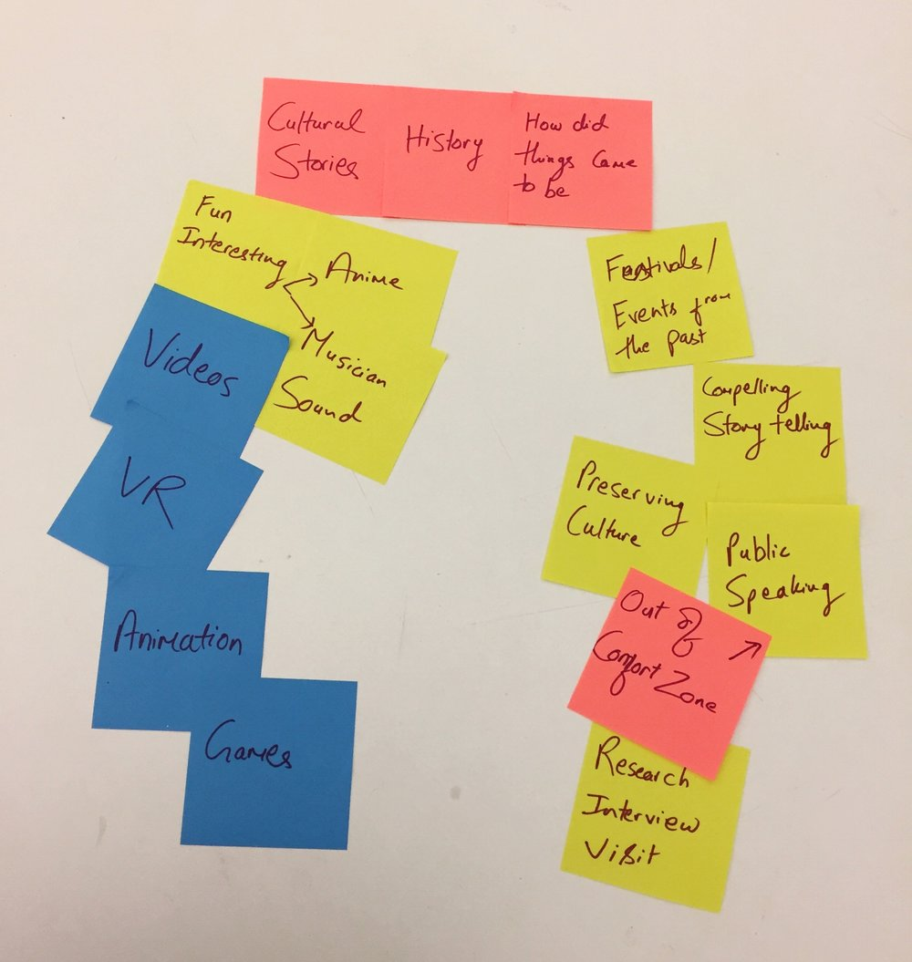

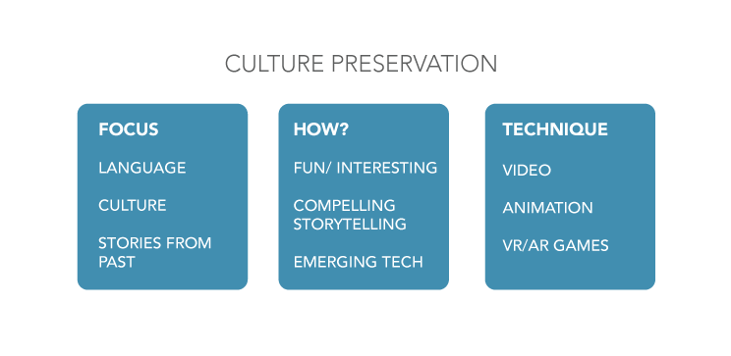

Preservation of my indigenous endangered language

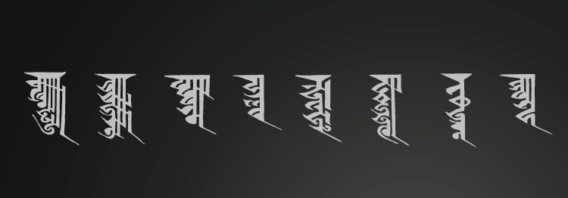

I am focusing on the preservation of my indigenous language called Newari which is recognized by the UN as one of the most beautiful languages in the world through the means of emerging technology.

The proper name is Nepal Bhasha meaning Newari Language. The earliest occurrence of this language is dated back to 1380AD. It is as old as the indigenous people of the capital. There was a settlement here since the prehistoric time when Manjushree visited from Wutai Shan in China. Hence, the linguists call it a Tibeto-Burman family language. The Ranjana Script used in Nepal Bhasha is the only indigenous script of Nepal. The script was widely used in olf Buddhist texts found in Tibet, China, Mongolia, Japan, Korea, Vietnam and other Buddhists Nations.